

NEW ZEALAND MARITIME SCHOOL
NZ Diploma in Marine Electro-technology (NZ2894)
(STCW 1978 A-III/6, as amended in 2010)
Electro-Technical Officer, Year 2 Cadets, 2020.

Course Code
942.646 - AS01.

Course Title
Maintenance and Repair of Control and Safety Systems of Shipboard Hotel Equipment Learning Outcomes Assessment.

Format
Written assignment of 1500 words including diagrams and marked Competent (C) or Not-Yet Competent (NYC). Weighting = 50%.

Due Date
To be submitted by email to nick.cossar@manukau.ac.nz for the due date of 09/08/2020.

Tutor
Nick Cossar
nick.cossar@manukau.ac.nz

Student Name: Levi Dubbelman

Student ID: 190000929

Date: 1/09/2020
Investigate Electrical and Mechanical Control and Safety Systems used in a modern ship’s
elevator system as per learning Outcome 1: Demonstrate advanced knowledge and
understanding of elevators.

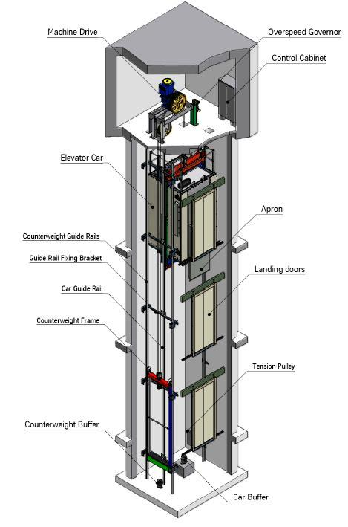

Describe main parts of vessel elevator
Component | Description
Shaft | The shaft is the primary component of the elevator. It houses the primary components of the elevator, and houses rails which allow the car to travel between floors.
Pit | The majority of elevators require an elevator pit below the first floor landing. This pit is constructed to house the base of the elevator rails, the jack hole and the piston, as well as the impact equipment for the cab.
Machinery Room | The room above the elevator shaft which houses the motor, motor drive, brake system, and PLC (if equipped) as well as the termination point for any limit switches within the shaft.
Electric Motor | Typically a three-phase induction motor, housed in the machinery room, which drives the elevator car against the force of the counterweight
Brake | A physical locking device which prevents the elevator from moving up or down when successfully docked on a landing, and may also engage following a catastrophic failure.
Drive | Typically a three-phase variable speed drive which converts a fixed frequency, fixed voltage power supply into a variable frequency waveform to provide speed control to the electric motor. Generally pre-programmed with a ramping curve for passenger comfort.
Car | The moving platform which passengers or cargo rest upon. Generally has solid walls and roof to prevent direct passenger access to the shaft and/or moving/rotating components or to prevent loose cargo from falling into the shaft.
Counterweight | A solid weight designed to keep the car in suspension to reduce the effort required by the motor to move the cabin, as well as to reduce the chances of a free-falling car.
Car Door | Door located on the car itself which opens when a signal is received indicating that the car has arrived and docked at a landing successfully.
Landing Doors | Doors located at each and every landing which prevent passengers entering into the shaft without a car being docked there.
Hoisting Ropes | Steel cabling which directly affixes the car to the counterweight, as well as to the motor.
Over-speed Governor | A system designed to absorb additional kinetic energy to slow down the elevator in the event that the car travels beyond its rated speed.
Tacho-generator | A transducer which directly converts rotational velocity to a voltage which is then supplied as a useful signal to an analogue PLC input.
Control Cabinet | The cabinet housing the PLC or other controller with inputs for limit switches, button presses, tacho-generators, load cells in addition to outputs for signalling the motor/car doors.
Cabin Call System | Buttons located within the cabin to allow direct passenger influence in which landings the car will arrive at.
Explain elevator working modes
Mode | Description
Normal | The standard operation mode. In this mode, passengers may call or send the elevator to any whitelisted landing.
Learning | In this mode, the elevator is capable of using a predictive model to reduce congestion and increase efficiency by self-identifying frequent landing sequence combinations, as well as drive characteristics. This is typically reserved for elevators with several dozens or hundreds of landings.
Priority | In priority mode, elevator call functions are overridden for that particular car, enabling the operator to send the car directly to any given floor. This is reserved for elevators with an in-elevator attendant or for VIP users.
Fire | In fire mode, all cars will immediately travel to a pre-determined landing (generally the ground floor) and ignore any further call or send functions.  In addition, an operator override key located in the car will allow firefighters to utilize the elevator.
Hospital | In hospital mode, a medical emergency button located on a floor has been pressed. This overrides any call or send functions and instead sends the car closest to the emergency to that floor immediately. That car is then taken off the roster until the medical emergency subroutine has concluded.
Luggage | In buildings with luggage storage, an attendant may use this mode to travel to and from those floors, whereas a civilian may not, for security reasons.
Inspection | This mode takes a specific car off the roster and allows for inspection workers to manually operate the car for diagnostic purposes.

Explain operation of elevator safety devices
Device | Function
Safety Circuit | Limit switches provide critical feedback to the control cabinet, including over travel and positional information. In addition, the tacho-generator reads and over/under velocity alarm.
Emergency Stop | Allows an operator/passenger to immediately brake the car and disconnect the motor from the drive in event of imminent risk to health.
Car Door Light Barrier | Prevents passengers from being caught within the car or landing doors with an infrared sensor which goes HIGH when it the flow of light is interrupted.
Over speed Governor | Absorbs kinetic energy to dampen the speed of the elevator car smoothly. Can sometimes use fly ball or fly wheel weights.
Over current Protection | Prevents damage to the drive or motor in the event of excessive load (weight on car) or a short-circuit or earth fault condition.
Trapped Alarm/Intercom | Allows passengers/operators within the cabin to communicate with staff who can then offer assistance in the even of catastrophic failure.
Describe maintenance procedures for main elevator components
Component | Maintenance Procedure
Hoisting Ropes/Pulleys | Constant preventative maintenance, including regular inspection, and lubrication. In the event of damage, the entire rope must be replaced by lowering the car to rest on its buffer, then doing the same for the counterweight, and hoisting in a new rope.
Shaft Equipment | Limit switches, light barriers, as well as car guides, doors and landing doors can be serviced by placing the elevator into "inspection mode" and allowing staff to enter the pit or, if necessary, ride on top of the car. A harness should be worn if working beyond the confines of the landing door, or if on top of the elevator car.
Car guides/car doors
Landing Doors
Electric Motor/Gearbox | The motor and gearbox can be directly serviced with the drive de-energized and the car at rest on its buffer.
Motor Drive/Control Cabinet | The drive is likely to be replaced rather than serviced, as is the PLC. However both may be interfaced with directly while in operation, if the relevant software/access keys are acquired.

